Chapter 6-[Relations](https://mfleck.cs.illinois.edu/building-blocks/version-1.3/relations.pdf)

Thursday, December 29, 2022

11:21 PM

***Relations:***



(R is a set of ordered pairs that are made with elements taken from A that fit a specific criteria/relationship)



If x is related to y,



If x is not related to y.

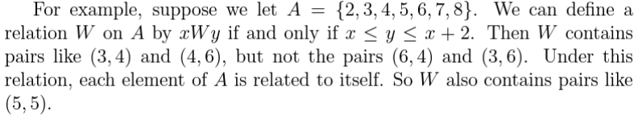

Relation graph:

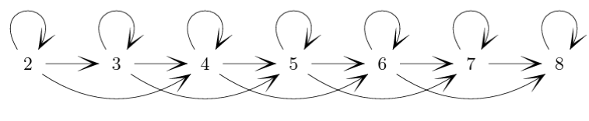

Graphs can also look like:

X ≡ y (mod 3)

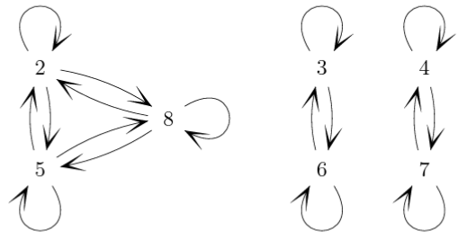



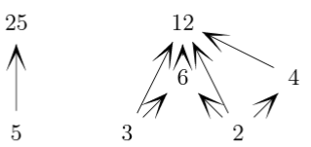

***Relation Properties:***

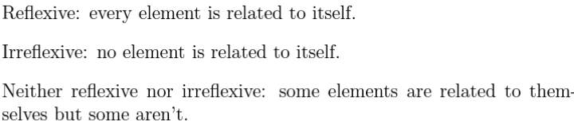

(note that the inverse/negative of reflexive is NOT irreflexive!)



***Symmetric***: if xRy in R, yRx is also true. Mostly occur in relations that resemble equality, like



(**only** 2-way arrows in relations graph)



***Antisymmetric***: if xRy in R, yRx is not true. Mostly occur in relations that put elements into an order, like



(**only** 1-way arrows in relations graph)

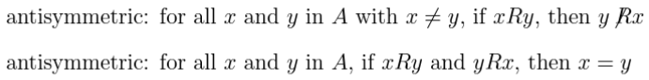

(both definitions are equivalent)

***Transitivity:***



(transitivity means that whenever there is an **indirect** path from x to y, then there must also be a **direct** arrow from x to y)



Note that the transitivity definition is a condition, so again if the "if" part is false, then the statement is true regardless.

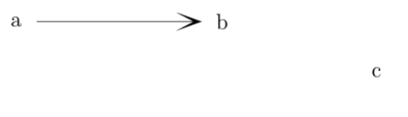

*(This thing is transitive, even though there's no arrow from a to c)*

***Types of Relations:***

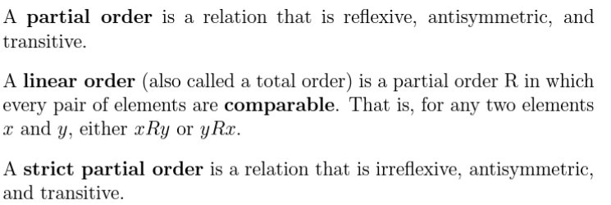

*(Think of Linear Orders like relating all integers with ≤, every integer can be related to another random integer using ≤)*

*(Think of Partial Orders like Linear Orders but some pairs of elements are not related. For example, for divides, 5 doesn't divide 7, and 7 also doesn't divide 5)*

*(Think of Strict Partial Order like a Partial Order except elements are not related to themselves.)*



If R is some specified relation on a set A, and x is an element in A, the equivalence class of x is all elements y where xRy.



*(Equivalence Relation is like the general case/definition of relations like Congruence Mod k on the set of integers)*

***Proving that a Relation is an Equivalence Relation:***

Just take the relation and prove all 3 conditions (reflexive, symmetric, and transitive) individually

Example:

Let F be the set of all fractions

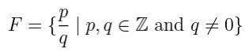

So:



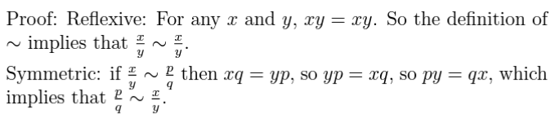

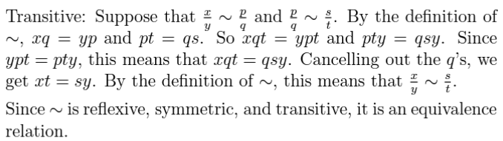

Same process when trying to prove other kinds of relations: split the proof into multiple parts and prove each requirement one by one.

(For example: proving antisymmetry:

